Web Specifications
Website Objective
The purpose of this website is to provide a professional digital platform for a football club named Ditswametsing Football Club. The website aims to improve fan engagement by giving them an opportunity to access match fixtures, player statistics and log standings through a centralized platform. The websites serves as a formal online platform for potential sponsors,scouts and partners to be updated with current information of the club.
Web development practices highlights the importance of accessible platforms,as these greatly improve user engagement and information accessibility.

Target Audience
The website can be used by local football fans, players ,sports followers aged 7 - 40 years old and journalists seeking quick and reliable updates for primary users. For secondary users, it can be used by potential sponsors, club administrators, and management. For technical skill level, the audience is expected to have an average level of technical skill with most users accessing the website via mobile devices. Therefore, the website will be designed to ensure ease of navigation, fast loading times and responsiveness.
Website Type
The website is informational as its primary purpose is to provide structured and real time information related to the football club. It works as a digital archive and informational portal rather than an e-commerce platform.
Information Design and Taxonomy
The website follows a hierarchical structure to ensure all content is accessible within the 3 click rule, improving usability and navigation efficiency.

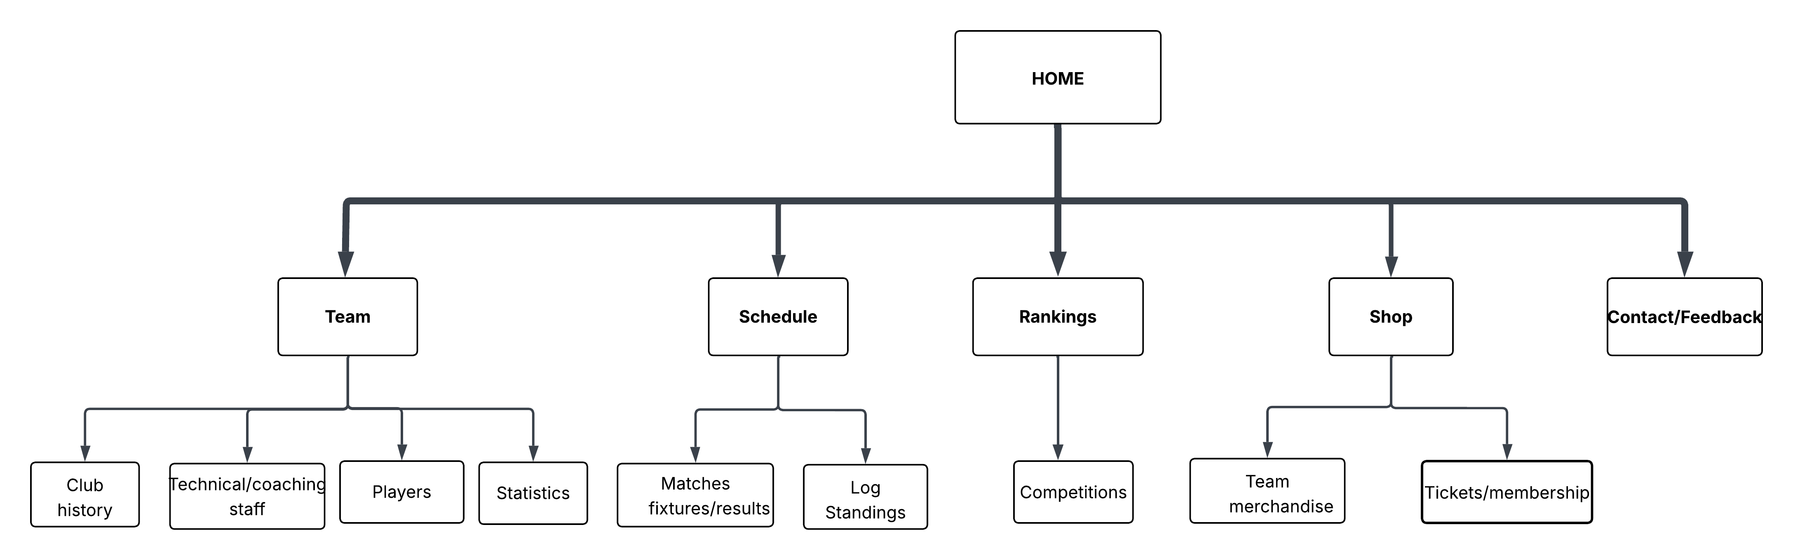

Home Page: The welcome message, the hero banner (match ball image) and the latest news updates are displayed there.
Team Page: shows the profiles of club history, technical/coaching staff, players and player statistics.
Schedule Page: Displays log standings, future games and recent matches
Ranking Page: Shows the competitions of the team
Shop: Shows the team merchandise and price for tickets and membership
Contact Page/Feedback: This page has an HTML5 form with which a user can interact
Taxonomy and Navigation
The information is divided into major sections:
Teams (Players)
Schedule (Matches)
Rankings (Competition)
Shop(tickets)
The navigation is applied by means of a regular Bootstrap navigation bar on the top of each page. This will be used to maintain constistency,convenience and a smooth user interface on every page.
Page Template Design
The site will be designed with a common page layout throughout the site to maintain consistency and usability.

Design Explanation
The branding will include the name and logo of the club in the header.The navigation bar makes navigation easy.The hero banner offers aesthetics and emphasis of content.The primary content zone shows up to date information like team statistics and game outcomes.The footer has contact and social media links.The structure of this design offers readability,white space and easy interface.
Technical Brief
This section identifies technologies and tools that were utilized to create the web site as per the three-layer web development model.
Structural Layer
The site will be made with the help of HTML5,which will provide it with the appropriate semantic structure and accessibility.Details like headings,sections,and tables will be appropriately used.As an illustration the Competitions page will have tables that show league standings in a clear way.
Presentation Layer
CSS3:CSS will be employed to have a consistency in design across all the pages through the use of an external stylesheet .Bootstrap 5 is based on the creation of a responsive design which can be used to support various screen sizes.
Behavioral Layer
JavaScript:This is used to provide interactivity on the client side especially form validation on the feedback page.This is to make sure that the users fill in all the necessary fields.
Development & hosting tools
Visual Studio Code(VS Code):It is the main code editor because the tool is flexible and it allows the addition of extensions.
GIMP:Image editing e.g. player photos and banners.
Github:This is a version control and project file management tool.
Github Pages:This is used to host and make the site online

